Week 2: 1-5 June 2026
This week, I mainly focused on dataset selection, yolo model selection, and software environment setup.

1. Real World Problems
One of our goals is to identify issues in the current traffic system and solve them with our project.

1.1 Transit System in Saskatoon
There are some issues with Saskatoon’s transit system. Classified by locations (color):
Red – roads, Yellow – roads & stations, Green – stations
Problems | Possible solutions (with YOLO)
Winter weather can cause bus delays and service disruptions [1] | Detect snow accumulation and other conditions on road
Snow and Ice management is costly [2] | Determine which road requires priority processing
Snow facilities need accurate data for management decisions [3] | Detect truck count (queue, and snow unloading area occupancy)
Cities need better KPIs and performance monitoring [4] | Quantitative KPIs, such as road blockage rate, snow-clearing rate
Real-time traffic information relies on GPS and passenger feedback [5] | Detect crowding level (traffic & passages)
Safety risks of waiting for a bus in winter or dark conditions [6] | Detect whether passengers are too close to the curb
Buses should stop less often and for shorter periods of time [7] | Detect station crowdedness for drivers

1.2 Belisha Beacon (Yellow Ball Light) in Hong Kong
Belisha beacons in Hong Kong will indicate whether a crossable road has vehicles coming and pedestrians crossing:
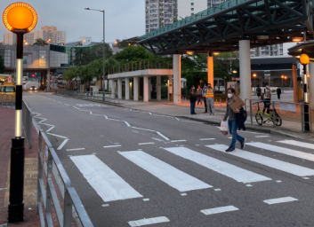
Potential problems with the current version:
- Latency on edge devices
- False positives in summer (thermal sensing)
- False negatives when someone stops for a long while (motion sensing)
- Hard to detect when crowded (thermal sensing)
This is an interesting application, but for projects in Canada, snow-related traffic problems are more practical and directly connected to local needs.

1.3 Next Step
There are more real-world traffic problems other than these, which can be solved by a fast YOLO model that detects:
- Vehicles
- Humans
After some research, I still do not have a clear target for an edge device fast YOLO to solve. However, the project can potentially solve multiple problems. (We will determine the target in the future)

In the next section, I will discuss a dataset to train a YOLO model for it.

2. Dataset Selection (YOLO Image Detection)
The dataset is selected based on the camera location, labels, and their literature support. I selected some fixed-position road camera datasets and compared them:
Dataset | Location(s) | Labels (classes) | Total sample count
MIO-TCD Localization [8] | Canada and United States | 11 labels  - Articulated Truck  - Bicycle  - Bus  - Car  - Motorcycle  - Non-Motorized Vehicle  - Pedestrian  - Pickup Truck  - Single-Unit Truck  - Work Van  - Motorized vehicle  (Per-class sample count: unknown) | - 786 702 total frames  - 137 743 localization frames  - 416,277 labeled instances (bounding boxes)
Montréal Annotated Traffic Camera Images [9] | Canada (Montréal) | 5 labels  - Vehicles  - Pedestrians  - Construction objects  - Cyclists  - Buses  (Per-class sample count: unknown) | (Total Sample count: unknown)
TSBOW [10] | South Korea | 8 labels  Per-class samples / manual labeled:  - Car 50 269 953 / 783 203  - Bus 2 252 616 / 35 715  - Truck 565 932 / 10 657  - Small Truck 3 258 031 / 58 272  - Pedestrian 2 935 102 / 53 414  - Micromobility 1 691 744 / 29 959  - Unidentified 515 447 / 8 379  - Others 9 648,223 / 151 556 | - ~3 200 000 labeled frames  - 48 061 manual labeled frames  - 71 137 048 labeled instances  - 1 131 155 manual labeled instances
TrafficMOT [11] | India (8 cities) | 10 labels  - 9 types of vehicles  - Pedestrian  (Per-class sample count: unknown) | - 2 102 videos  - 105.1 minutes  - average 22.8 objects per frame  - 78 videos are fully annotated across all 30 frames  - 2 024 videos only have the first frame annotated
UA-DETRAC [12] | China (Beijing and Tianjin) | 4 labels  Per-class samples  - Car ~1 046 892  - Bus ~44 649  - Van ~107 448  - Others ~10 890 | - 100 videos  - > 140 000 frames  - 1.21M labeled instances
WebCamT / CityCam [13] | United States (New York) | 10 labels  - Taxi 113k  - Black sedan 240k  - Other cars 259k  - Small truck 12k  - Medium truck 19k  - Big truck 4k  - Van 27k  - Medium bus 7k  - Big bus 17k  - Other 19k  (Without pedestrian) | - 60 000 labeled frames  - 717 947 labeled instances
BMD-45 [14] | India (developing cities) | 14 labels  - Cycle  - 2-Wheeler  - 3-Wheeler  - Hatchback  - Sedan  - MUV  - SUV  - Van  - Tempo Traveler  - Minibus  - Bus  - LCV  - Truck  - Other  (Per-class sample count: unknown)  (Without pedestrian) | - 45K images  - 480K labeled instances  - > 3.6K operational CCTV cameras
Remark:
for unknown sample counts, downloading the dataset is necessary to get the amount.
The strengths are highlighted in green.

After some consideration, I found out that it would be good if a dataset matches the following three conditions:
- Traffic images in Canada
- Labeled at least with vehicles, pedestrians
- Had a decent literature support

MIO-TCD Localization is selected because it best matches the project’s current requirements: North American traffic-camera scenes, bounding-box annotations, vehicle and pedestrian classes, and peer-reviewed literature support. Although it is older than some recent datasets, it is geographically and semantically closer to the Canadian traffic-monitoring scenario than the other candidates.

2.1 Dataset: MIO-TCD Localization
Based on the support literature [8], here is some basic information:
- The dataset is created with the target of performing image detection in a single video frame

- Dataset structures:
- 137 743 images for training
- traffic scene with bounding boxes
- 416 277 moving objects tagged bounding box and class label
The dataset provides bounding-box annotations and class labels, so it can be converted into YOLO annotation format for object detection training.

- With bounding box annotation, for example:
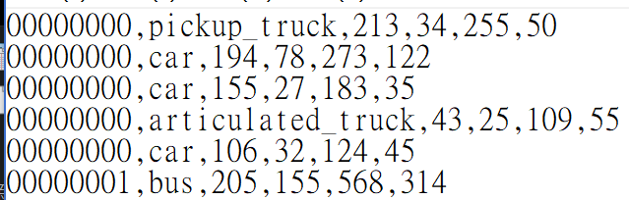

- Data are traffic camera images, with different times and backgrounds, for example:
Daytime, clear  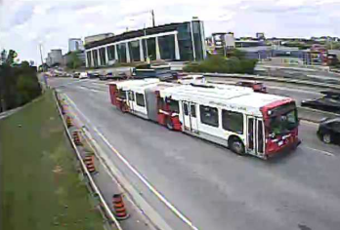 | Daytime, snowy  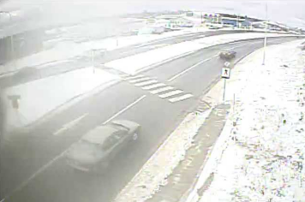 | Nighttime, clear  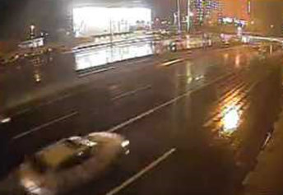 | Nighttime, unclear  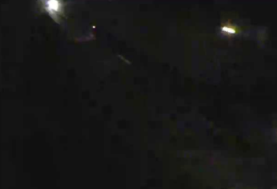

- Tested with the following image detection models:
- Faster R-CNN
- SSD-300
- SSD-512
- YOLO-v1
- YOLO-v2

To conclude, MIO-TCD:
- Is a large-scale real-world traffic camera dataset designed for traffic localization
- Provide full-frame bounding-box annotations
- Provide benchmark results for models such as CNN, SSD, and YOLO
Making it highly suitable for YOLO-based smart traffic detection projects.

3. YOLO Baseline Model
Our target is to run a YOLO model on embedded devices. To achieve that, a small model is needed. First, by comparing different YOLO models mainly with three factors:
Factor | Mainly affecting | Affections
Parameters | Size (RAM) | Higher: larger, smarter
Weight size | Size (hard disk, VRAM) | Higher: larger
Floating Point Operations (FLOPs) | Speed | Higher: slower
Mean Average Precision (mAP) | Accuracy | Higher: more accurate
- Weight size is rarely provided. For weight size FP32, it could be estimated by parameters p*(4 bytes) (for FP16: p*2b, INT8: p*1b). Therefore, weight size will not be listed.
- For mAP: mAP50-95 needs more accurate boxes than mAP50 to pass.

YOLO models (strong factors highlighted in green, decent in yellow, bad in red):
model | Parameters | FLOPs, resolution | mAP50-95
YOLOv3-tiny | 8.848M | 5.582G, 416 | Unk
YOLOv4-tiny | 6.0535M | 6.9289G, 416 | 22.66%
YOLOv5n | 1.9M | 4.5G, 640 | 28.0%
YOLOX-Nano | 0.91M | 1.08G, 416 | 25.3%
YOLOv6Lite-S | 0.55M | 0.56G, 320 | 22.4%
YOLOv7-tiny-SiLU | 6.2M | 13.8G, 640 | 38.7%
YOLOv8n | 3.2M | 8.7G, 640 | 37.3%
YOLOv9-T | 2.0M | 7.7G, 640 | 38.3%
YOLOv10n | 2.3M | 6.7G, 640 | 39.5%
YOLO11n | 2.6M | 6.5G, 640 | 39.5%
YOLO12n | 2.6M | 6.5G, 640 | 40.6%
YOLOv13-N | 2.5M | 6.4G, 640 | 41.6%
YOLO26n | 2.4M | 5.4G, 640 | 40.9%
When considering the YOLO model, the order is: accuracy > size > speed.

YOLO26n’s size and speed outperformed every models that achieving decent accuracy, while YOLOv13-N had the highest overall accuracy. The baseline model should be decided between them:
model | Parameters (size) | FLOPs 640 (speed) | mAP50-95 (accuracy)
YOLOv13-N | 2.5M | 6.4G | 41.6%
YOLO26n | 2.4M | 5.4G | 40.9%

The accuracy of YOLOv13-N is slightly higher than YOLO26n:
- YOLOv13-N is 0.7 percentage points higher than YOLO26n, which is about 1.7% relatively higher

The parameters of YOLO26n are slightly smaller than YOLOv13-N:
- YOLO26n uses about 96% of the parameters of YOLOv13-N

The FLOPs of YOLO26n are lower than YOLOv13-N:
- YOLO26n uses about 84.4% of the FLOPs of YOLOv13-N

Since the size and speed of YOLO26n are relatively better than YOLOv13-N (although the accuracy is 0.7% lower), the final choice would be YOLO26n.
Our contribution is to analyze and make that model proportionally smaller at the cost of a slight loss in accuracy (SW side). After that, we accelerate our proposed model on embedded SoC devices (HW side).

4. Software Toolchain
Although the YOLO model is selected, in case we may need to use another model, I planned the software toolchain for the top two candidate models: YOLOv13-N and YOLO26n.

4.1 First Step
- YOLOv13-N is implemented using the Ultralytics-style Python workflow. The YOLOv13 repository provides training, validation, prediction, and export examples using the Ultralytics YOLO interface.
- YOLO26n is also provided through the Ultralytics ecosystem. It supports model training and inference through the Ultralytics YOLO interface.

TFLite/LiteRT is primarily an on-device inference runtime, not the main training framework for YOLO models. The usual workflow [28] is to first train or fine-tune the model in a framework such as PyTorch, then export or convert the trained model into a deployment format such as ONNX, TFLite, NCNN, or MNN.

Therefore, the first step should be PyTorch / Ultralytics-based training and fine-tuning.

4.2 Intermediate Step
The PyTorch official documentation [29] states that PyTorch models can be exported to ONNX, which is an open standard that enables models to run across different hardware and runtime environments.

For this project, ONNX should be used as an intermediate model format because it helps connect the training framework with later inference runtimes and hardware-oriented deployment workflows.

4.3 Final Step
Due to limited PYNQ ARM/edge CPU resources, the final inference runtime should be a lightweight, low-dependency runtime that supports INT8/FP16 or mobile CPU optimization:
Final inference | description
ONNX Runtime | General inference runtime for ONNX models; useful for software baseline and cross-platform testing
OpenVINO | Optimized inference runtime for CPU-based deployment and model optimization experiments
NCNN | Lightweight neural network inference framework for mobile and embedded CPU inference
MNN | Lightweight inference engine for mobile phones and embedded devices
TensorRT | Useful for GPU-side reference benchmarking, but mainly NVIDIA-focused

ONNX Runtime will be used for software baseline testing. NCNN or MNN can be considered for lightweight ARM CPU inference. For the hardware-accelerated part, the model or selected layers should later be mapped to the PYNQ / FPGA workflow using Vivado, Vitis, Vitis AI, or custom overlays depending on the final hardware path.

4.4 To Summarize
By YOLOv13 GitHub / arXiv:
YOLOv13-N + PyTorch / Ultralytics → ONNX → ONNX Runtime / OpenVINO / NCNN / MNN
By YOLO26 Ultralytics / arXiv:
YOLO26n + PyTorch / Ultralytics → ONNX → ONNX Runtime / OpenVINO / NCNN / MNN

4.5 Setup Result
Tested with YOLOv5n PyTorch -> ONNX:
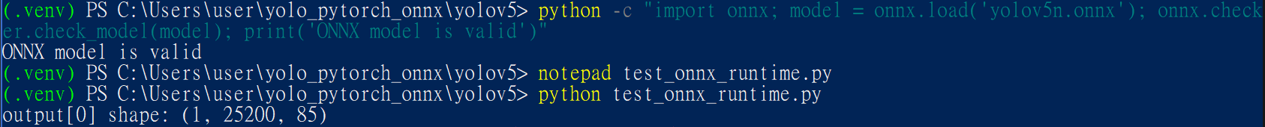
YOLOv5n ONNX model successfully ran by ONNX Runtime. I will do more testing and try YOLOv13-N or YOLO26n for the next step.

5. Week 2 Summary
For dataset selection, MIO-TCD Localization is selected as the initial training dataset because it provides North American traffic-camera images, bounding-box annotations, and both vehicle and pedestrian categories.

For model selection, YOLO26n is selected as the main baseline model for this project. Although YOLOv13-N has slightly higher accuracy, YOLO26n achieves a comparable mAP50-95 with fewer parameters and lower FLOPs, making it more suitable for embedded-device deployment and later hardware acceleration on PYNQ / FPGA-based platforms. Therefore, YOLOv13-N will be kept as an accuracy reference model, while YOLO26n will be used as the primary model for training, optimization, profiling, and hardware-acceleration experiments.

The next step is to train and evaluate YOLO26n on the selected dataset, and then analyze its latency, memory usage, accuracy, and hardware-acceleration potential on the embedded platform.

References

[1] Saskatoon Transit, Summer and Winter Weather, n.d. https://saskatoontransit.ca/rider-guide/summer-and-winter-weather

[2] City of Saskatoon and PwC, Snow and Ice Management Program Audit – Update/Dashboard, 2019. https://www.saskatoon.ca/sites/default/files/documents/final_snow_ice_dashboard_update_document_2019_march_13.pdf

[3] City of Saskatoon, Snow Management Facility User-Pay Model, 2020. https://www.saskatoon.ca/sites/default/files/Snow%20Management%20Facility%20Management%20User-Pay%20Model_SPCT_10Aug20.pdf

[4] City of Saskatoon and PwC, Snow and Ice Management Program Audit – Update/Dashboard, 2019. https://www.saskatoon.ca/sites/default/files/documents/final_snow_ice_dashboard_update_document_2019_march_13.pdf

[5] Saskatoon Transit, Mobile Apps, n.d. https://saskatoontransit.ca/plan-my-trip/mobile-apps

[6] Saskatoon Transit, Safety & Security, n.d. https://saskatoontransit.ca/rider-guide/safety-security

[7] Saskatoon Transit, Link - Bus Rapid Transit, n.d. https://saskatoontransit.ca/about-us/projects/link-bus-rapid-transit

[8] Luo et al., MIO-TCD: A New Benchmark Dataset for Vehicle Classification and Localization, IEEE TIP 2018. https://ieeexplore.ieee.org/abstract/document/8387876

[9] Canada government's open data dataset. https://donnees.montreal.ca/en/dataset/images-annotees-cameras-circulation?

[10] Huynh et al., TSBOW: Traffic Surveillance Benchmark for Occluded Vehicles Under Various Weather Conditions, AAAI 2026. https://arxiv.org/abs/2602.05414

[11] Liu et al., TrafficMOT: A Challenging Dataset for Multi-Object Tracking in Complex Traffic Scenarios. https://arxiv.org/html/2311.18839

[12] Wen et al., UA-DETRAC: A New Benchmark and Protocol for Multi-Object Detection and Tracking, CVIU 2020. https://www.albany.edu/faculty/mchang2/files/2020_01_CVIU_DETRAC.pdf

[13] Zhang et al., Understanding Traffic Density from Large-Scale Web Camera Data, CVPR 2017. https://openaccess.thecvf.com/content_cvpr_2017/papers/Zhang_Understanding_Traffic_Density_CVPR_2017_paper.pdf

[14] Sharma et al., BMD-45: A Large-Scale CCTV Vehicle Detection Dataset for Urban Traffic in Developing Cities, 2026. https://arxiv.org/abs/2604.24419

[15] Intel, yolo-v3-tiny-tf, 2023. https://docs.openvino.ai/2023.3/omz_models_model_yolo_v3_tiny_tf.html

[16] OpenVINO Toolkit, yolo-v4-tiny-tf, n.d. https://github.com/openvinotoolkit/open_model_zoo/blob/master/models/public/yolo-v4-tiny-tf/README.md

[17] Jocher et al., ultralytics/yolov5: v6.0 - YOLOv5n “Nano” Models, Roboflow Integration, TensorFlow Export, OpenCV DNN Support, 2021. https://zenodo.org/records/5563715

[18] Ge et al., YOLOX: Exceeding YOLO Series in 2021, 2021. https://arxiv.org/abs/2107.08430

[19] Meituan YOLOv6 Team, YOLOv6Lite Model, 2023. https://github.com/meituan/YOLOv6/blob/main/configs/yolov6_lite/README.md

[20] Wang et al., YOLOv7: Trainable Bag-of-Freebies Sets New State-of-the-Art for Real-Time Object Detectors, 2023. https://openaccess.thecvf.com/content/CVPR2023/supplemental/Wang_YOLOv7_Trainable_Bag-of-Freebies_CVPR_2023_supplemental.pdf

[21] Jocher et al., Ultralytics YOLOv8, 2023. https://docs.ultralytics.com/models/yolov8#performance-metrics

[22] Wang and Liao, YOLOv9: Learning What You Want to Learn Using Programmable Gradient Information, 2024. https://github.com/wongkinyiu/yolov9

[23] Wang et al., YOLOv10: Real-Time End-to-End Object Detection, 2024. https://docs.ultralytics.com/models/yolov10#model-variants

[24] Jocher and Qiu, Ultralytics YOLO11, 2024. https://docs.ultralytics.com/models/yolo11#overview

[25] Tian et al., YOLO12: Attention-Centric Real-Time Object Detectors, 2025. https://docs.ultralytics.com/models/yolo12

[26] Lei et al., YOLOv13: Real-Time Object Detection with Hypergraph-Enhanced Adaptive Visual Perception, 2025. https://github.com/iMoonLab/yolov13

[27] Jocher et al., Ultralytics YOLO26: Unified Real-Time End-to-End Vision Models, 2026. https://docs.ultralytics.com/models/yolo26#overview

[28] Google, LiteRT: High-Performance On-Device Machine Learning Framework, 2026. https://developers.google.com/edge/litert

[29] Wang et al., Export a PyTorch Model to ONNX, 2025. https://docs.pytorch.org/tutorials/beginner/onnx/export_simple_model_to_onnx_tutorial.html

